CPE301 – SPRING 2019

Design Assignment 1B

Student Name: Geovanni Portillo

Student #: 8000603824

Student Email: [portig1@unlv.nevada.edu](mailto:portig1@unlv.nevada.edu)

Primary Github address: https://github.com/portig1/submissions_E

Directory:

Submit the following for all Labs:

1. In the document, for each task submit the modified or included code (only) with highlights and justifications of the modifications. Also, include the comments.
2. Use the previously create a Github repository with a random name (no CPE/301, Lastname, Firstname). Place all labs under the root folder ESD301/DA, sub-folder named LABXX, with one document and one video link file for each lab, place modified asm/c files named as LabXX-TYY.asm/c.
3. If multiple asm/c files or other libraries are used, create a folder LabXX-TYY and place these files inside the folder.
4. The folder should have a) Word document (see template), b) source code file(s) and other include files, c) text file with youtube video links (see template).

1. **COMPONENTS LIST AND CONNECTION BLOCK DIAGRAM w/ PINS**

Atmel Studio 7

1. **INITIAL/MODIFIED/DEVELOPED CODE OF TASK 1/A**

;

; LAB1B.asm

;

; Created: 2/16/2019 1:06:49 PM

; Author : gausp

;

.include<m328pdef.inc>

.cseg

.org 0x00

.DEF ZERO = R10 ;Will be to add cary for the upper 8-bits of the sums

.DEF COUNTER = R25 ;R25 will be used as the counter

.DEF COPYVALUE = R20

.DEF NUM = R21 ;Defined variable for the division segment of code

.DEF DENOMINATOR = R22

.DEF QUOTIENT = R23

CLR ZERO

CLR R16 ;Clearing Registers R16:R19 since they will be used for the sum results

CLR R17

CLR R18

CLR R19

LDI COUNTER ,0x63 ;COUNTER = 99

LDI COPYVALUE,0x0A ;R20 = 10(initial value to be copied), will be incremented in till it is 109 but the last stored value will be 108

LDI XL,LOW(0x200) ;load the low byte of X with value STARTADS = 0x0200

LDI XH,HIGH(0x200) ;load the high byte of X with value STARTADS = 0x0200

LDI YL,LOW(0x400) ;load the low byte of Y with 0x0400

LDI YH,HIGH(0x400) ;load the high byte of Y with 0x0400

LDI ZL,LOW(0x600) ;load the low byte of Z with 0x0600

LDI ZH,HIGH(0x600) ;load the high byte of Z with 0x0600

L1:

ST X+, COPYVALUE ;Store R20 to memory location X

MOV NUM, COPYVALUE ;Copy R20 to NUM

LDI DENOMINATOR, 3

DIVLOOP1:

INC QUOTIENT

SUB NUM, DENOMINATOR

BRCC DIVLOOP1

DEC QUOTIENT

ADD NUM, DENOMINATOR

DIVCHECK:

CPI NUM, 0

BRNE NOTDIV3 ;If NUM = 0, R20 is divisible by 3 and will be stored in Y

ST Y+,COPYVALUE

ADD R16, COPYVALUE ;Adds value that's divisible by 3 to the appropriate sum

ADC R17, ZERO

RJMP NEXT

NOTDIV3: ;Stores value of R20 at Z since it is not divisible by 3

ST Z+, COPYVALUE

ADD R18, COPYVALUE ;Adds value that's not divisible by 3 to the appropriate sum

ADC R19, ZERO

NEXT:

INC COPYVALUE ;Increment value to store

DEC COUNTER ;decrement the counter

BRNE L1 ;loop until counter = zero

END: RJMP END

1. **DEVELOPED MODIFIED CODE OF TASK 2/A from TASK 1/A**

Verified results using google sheets @ <https://docs.google.com/spreadsheets/d/131Yni3C4D0n44uFcH8fwElzPeHHAXc-zYhx5vDc3qxU/edit?usp=sharing>

1. **SCHEMATICS**

No schematics

1. **SCREENSHOTS OF EACH TASK OUTPUT (ATMEL STUDIO OUTPUT)**

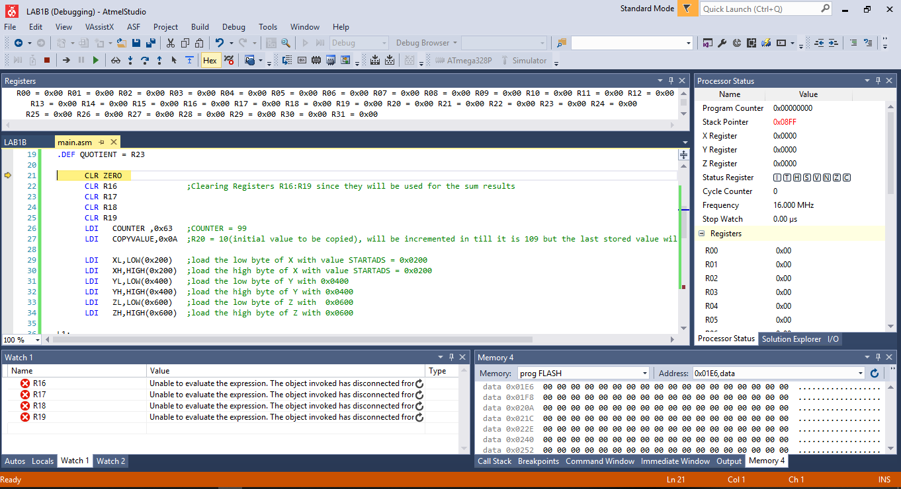

Values at start of debugging are shown. All registers are in their initial states.

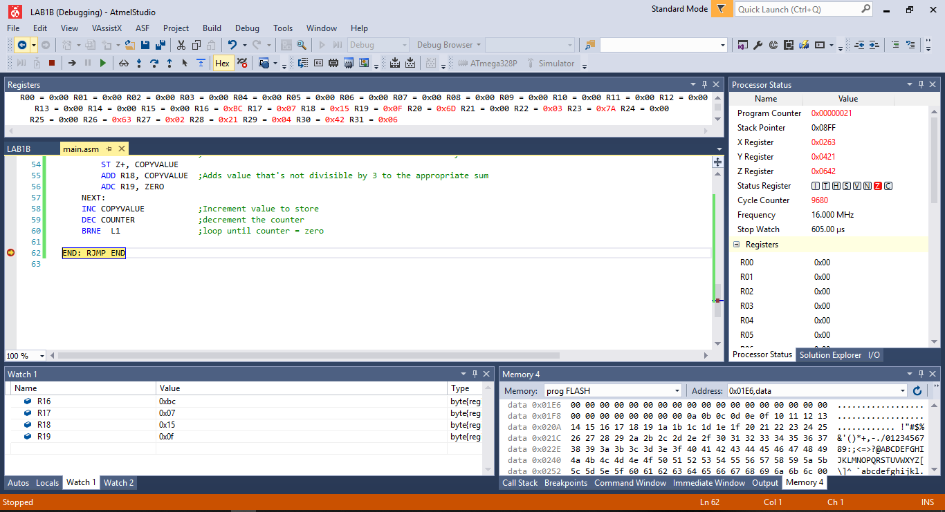

The values stored for X are shown as well as the total clock cycles of 9680 @ 16MHz with a time of 605us.

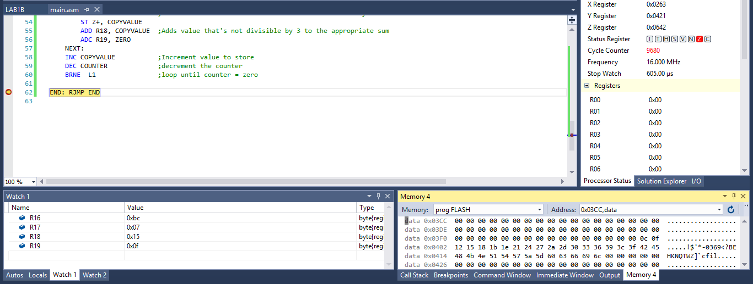

Values stored for Y are shown in the lower right-hand corner.

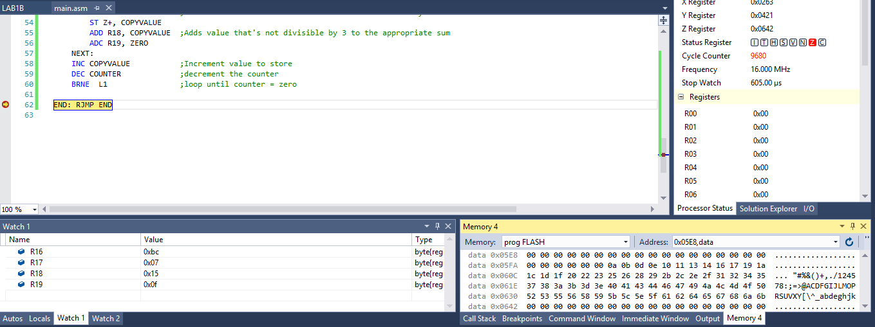

Values stored for Y are shown in the lower-right hand corner.

1. **SCREENSHOT OF EACH DEMO (BOARD SETUP)**
2. **VIDEO LINKS OF EACH DEMO**
3. **GITHUB LINK OF THIS DA**

**Student Academic Misconduct Policy**

<http://studentconduct.unlv.edu/misconduct/policy.html>

“This assignment submission is my own, original work”.

NAME OF THE STUDENT